 **Post Deployment Steps**

* **Enable community**

If community is not enabled, go to setup 🡪 search for community settings and click on Enable community.

* **Create a new community page**

Once community is enabled, go to setup 🡪 search for All Communities and click on it

and click on Create New Community of Type (Build Your Own)

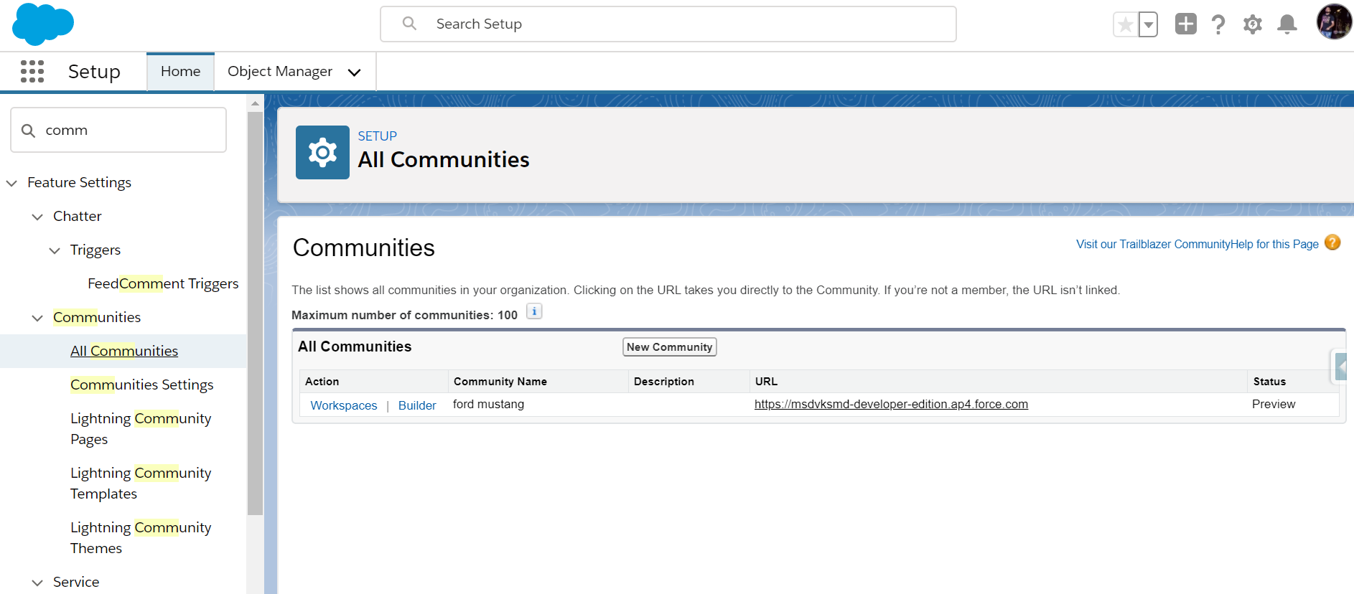

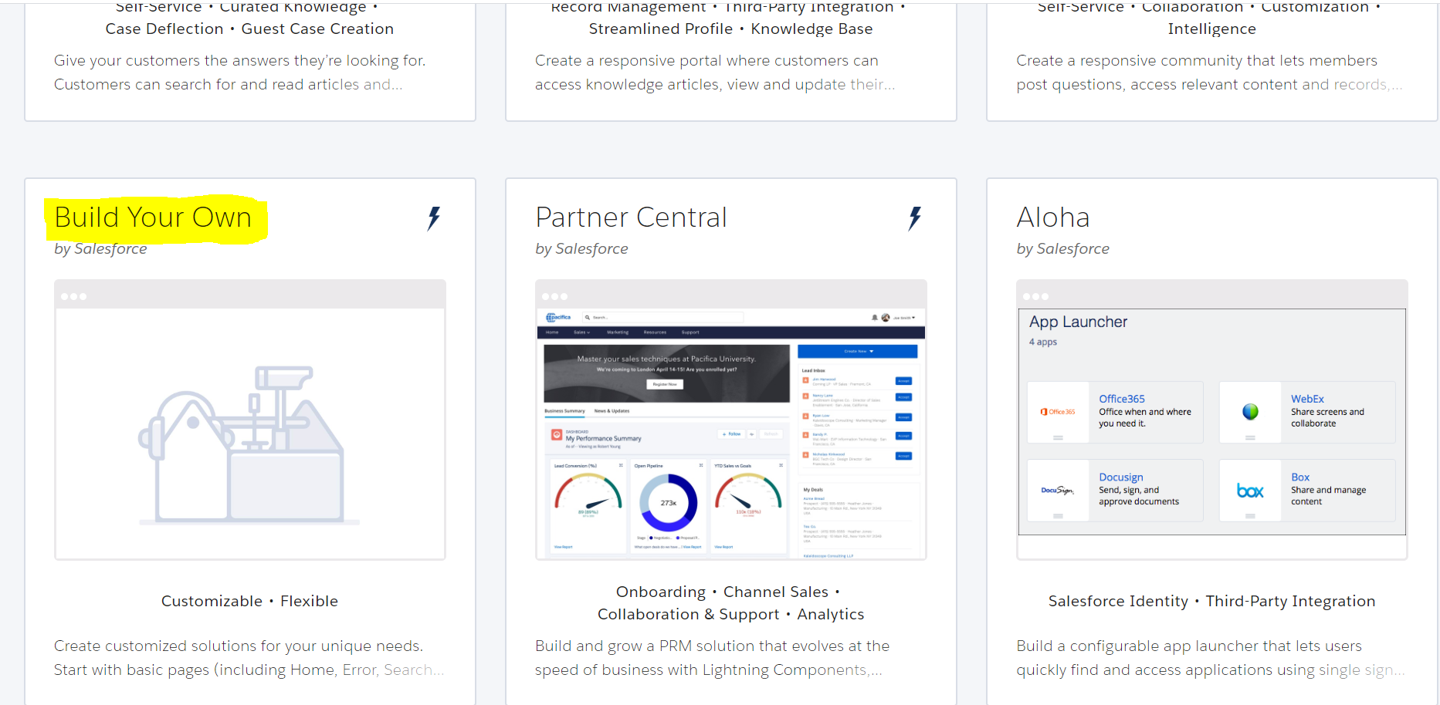

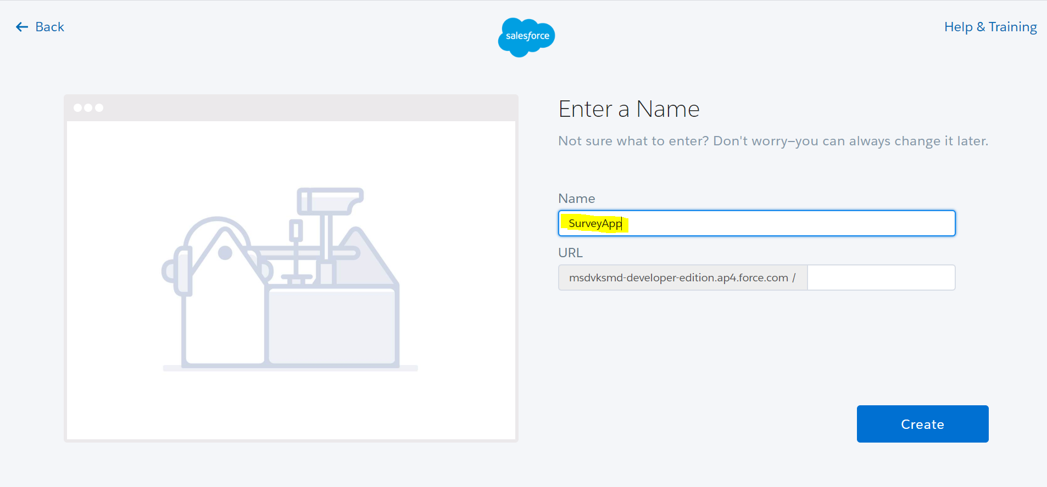

Copy the same name and update “Community_Name” custom label with it.

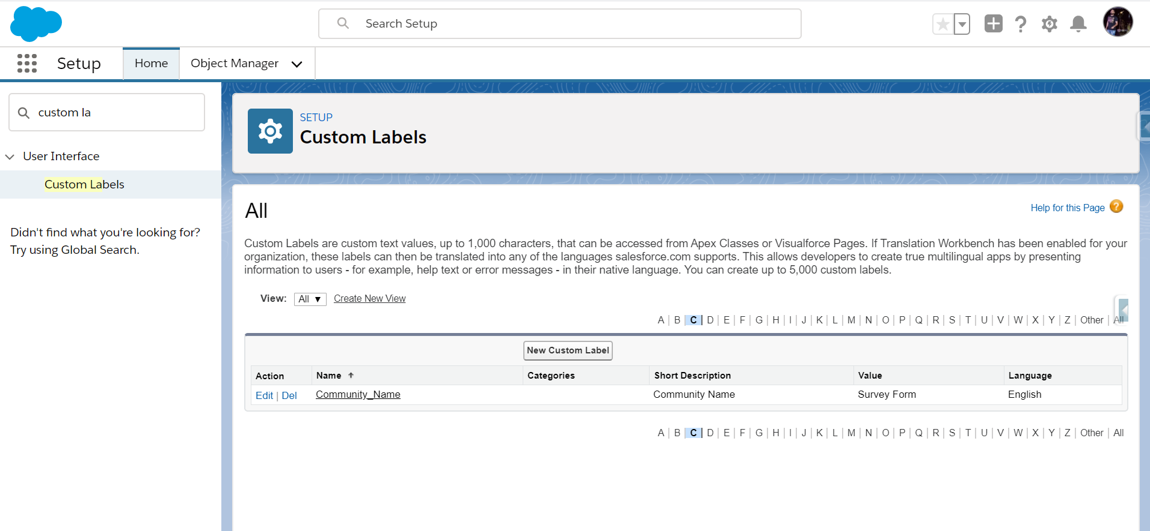

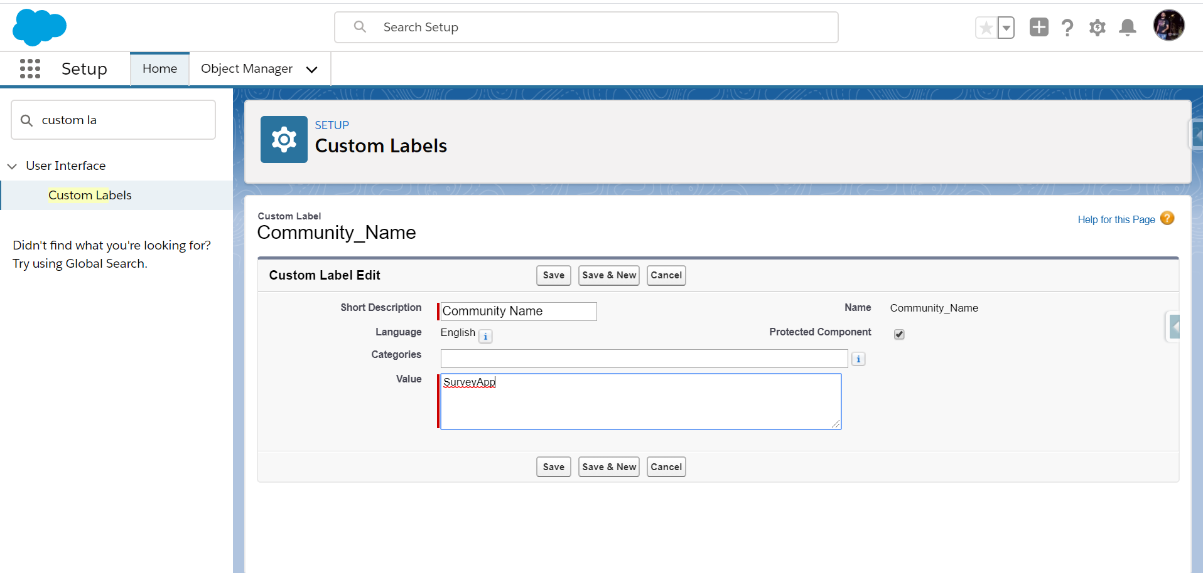

* **Drag drop the LWC component**

Go to community workspace (Builder), from components search for “surveyResponeForm”

And drag drop “surveyResponeForm” to content and publish community

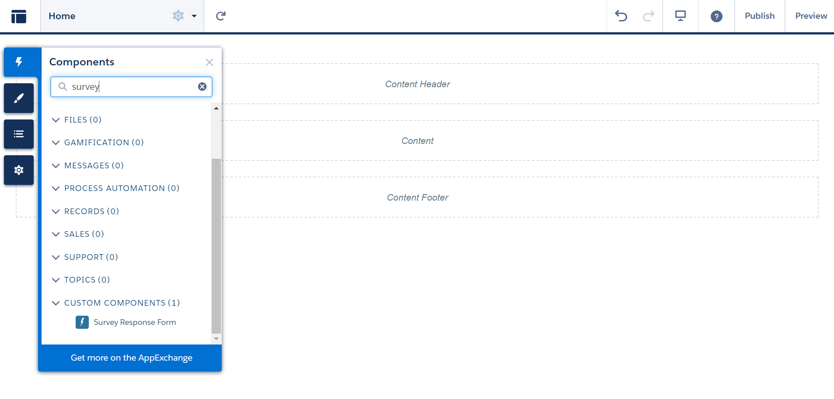

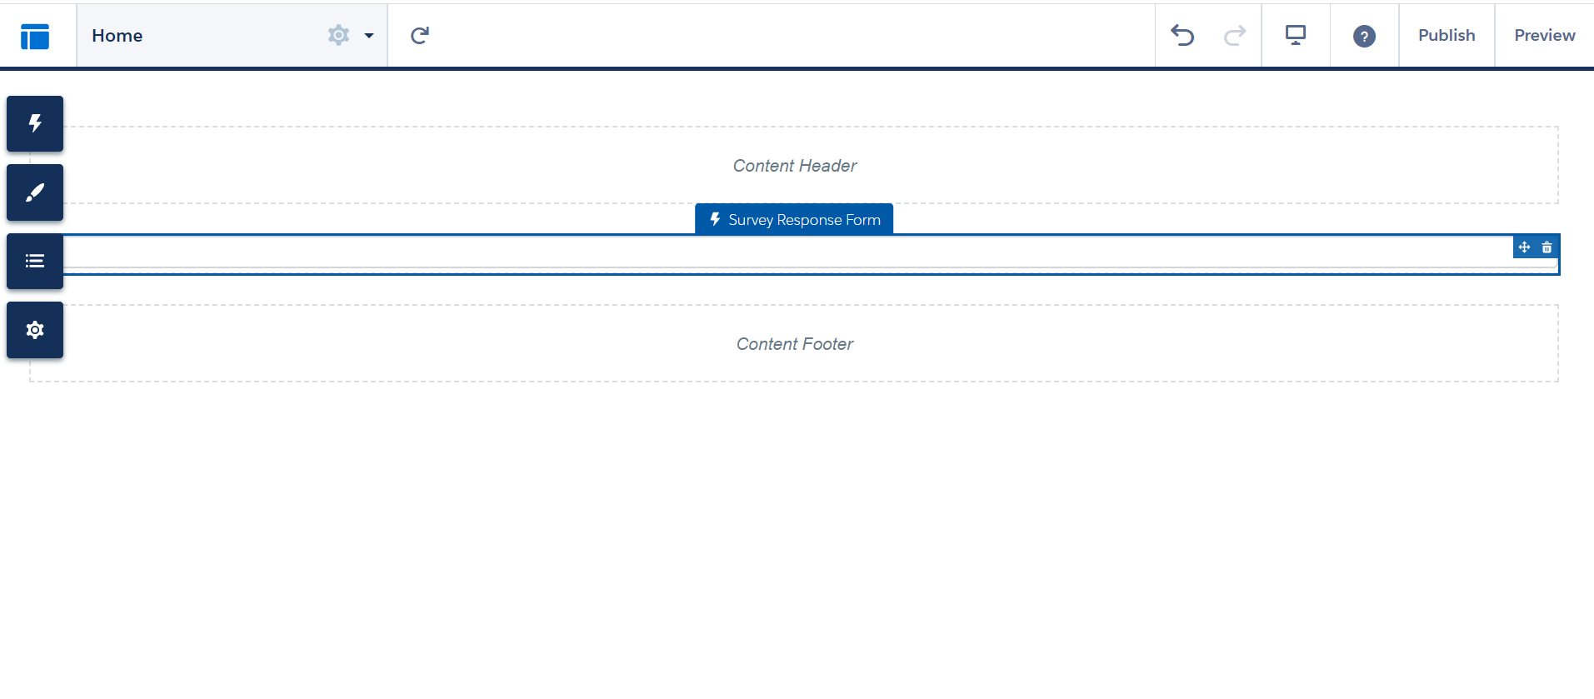

Publish community

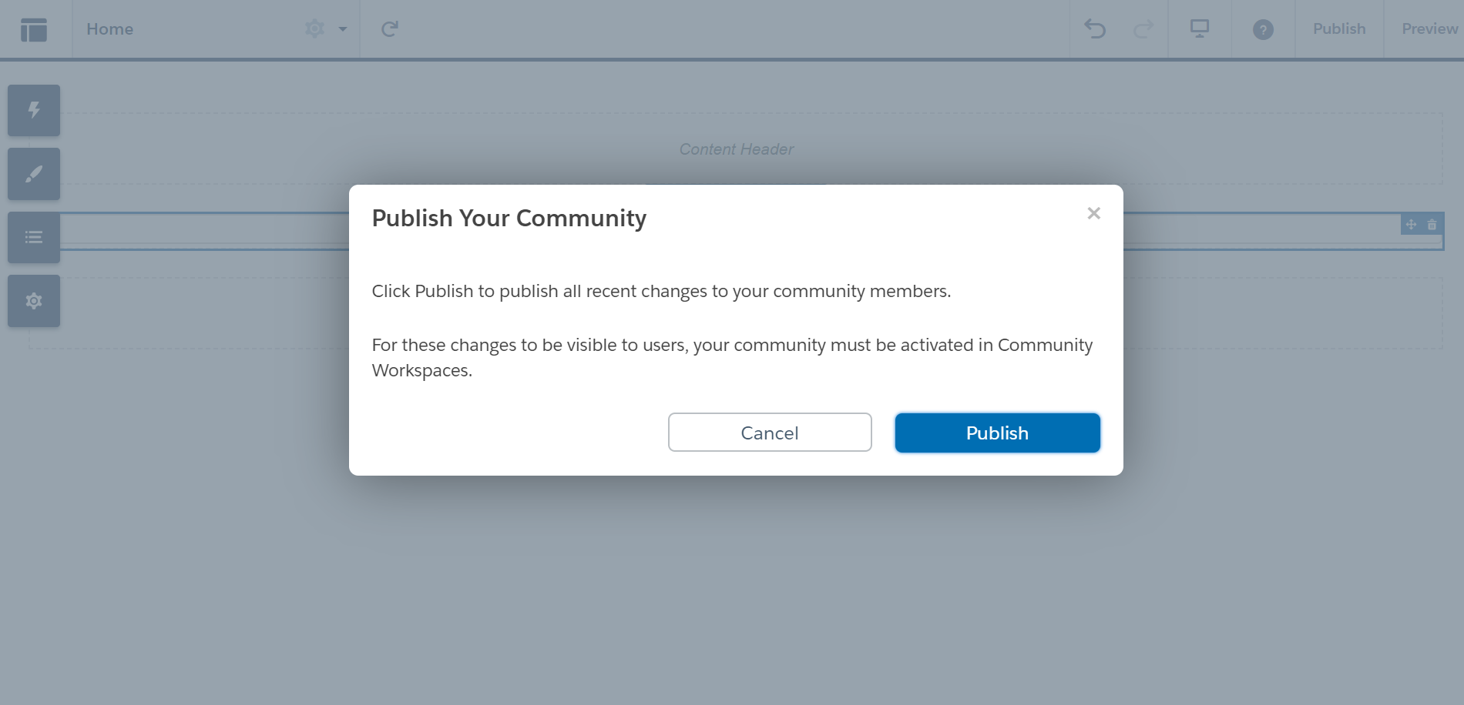

Hurray!!! All set now!! :)